Furniture Rental Form
Please fill in the order forms with the AMOUNT of your chosen items and send to us before September 26, 2019. There will be a 100% surcharge for on-site rental.
Contact Person: Mr. Ray Yang
Tel: +86 10 85896330/31 ext. 107 Fax: +86 10 85896318
Mobile: +86 18601976015 Email: chy_aloxbj@sina.com
No. | Picture | Dimension | Price / Whole Period(RMB) | Code | Amount  (RMB)
CHAIR AND TABLE:
1 | 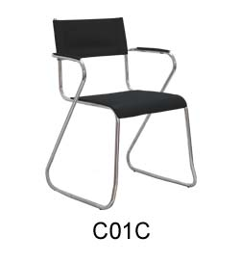 | 570x 440 x 760H | 75.00 | C01C
2 | 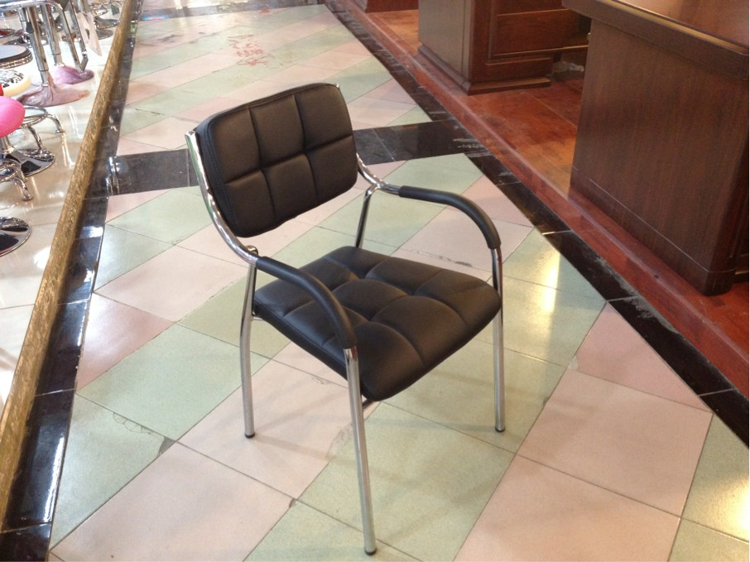 | 570x 500 x 760H | 110.00 | C02C
3 | 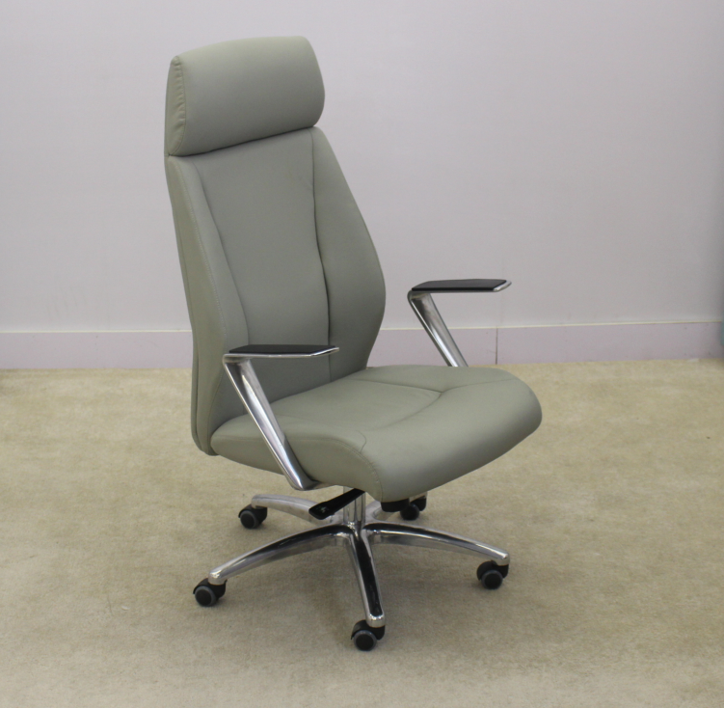 | 630 x 660 x1250H | 395.00
4 | 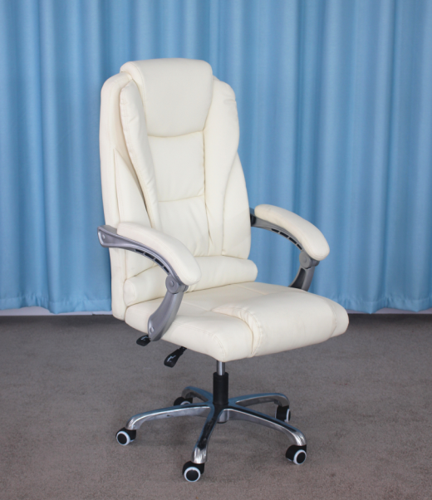 | 630 x 670 x1150H | 325
5 | 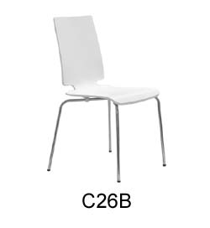 | 480 x 550 x800H | 125.00 | C26B
6 | 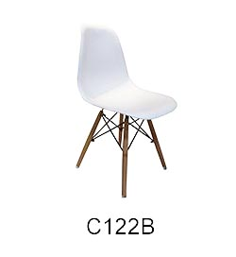 | 470*480*830H | 125.00 | C1222B
7 | 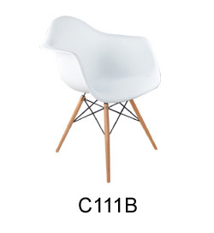 | 610*620*775H | 195.00 | C111B
8 | 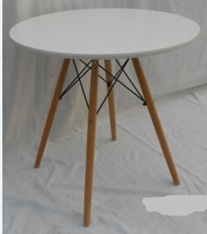 | 800*760H | 370 | RT30B
9 | 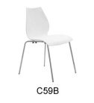 | 480*550*800H | 75.00 | C59B
10 | 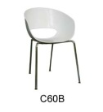 | 600*600*780H | 115.00 | C60B
11 | 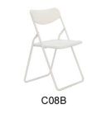 | 460*480*770H | 30.00 | C08B
12 | 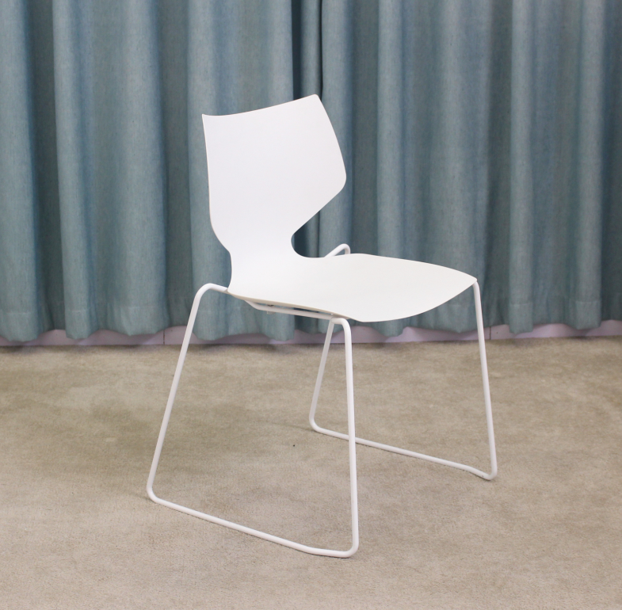 | 570*540*820H | 95
13 | 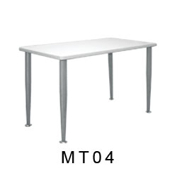 | 1400x700x 750H | 230.00 | MT04
14 | 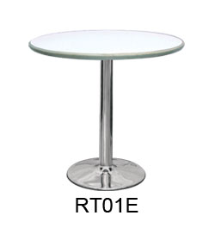 | 800￠x 750H | 150.00 | RT01E
15 | 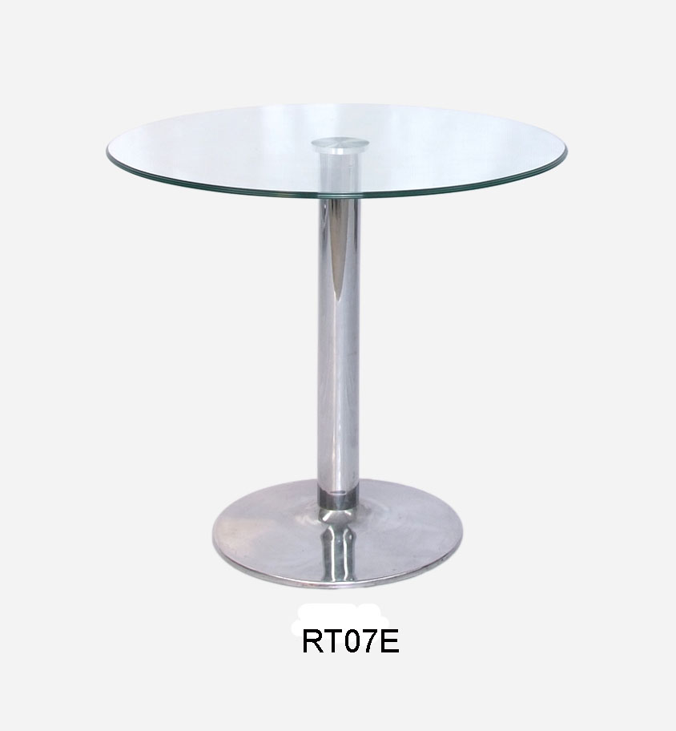 | 800￠x 750H | 150.00 | RT07E
16 | 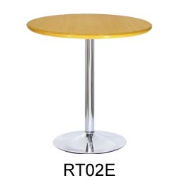 | 800￠x 750H | 150.00 | RT02E
17 | 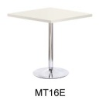 | 800￠x 750H | 150.00 | MT16E
BAR CHAIR AND TABLE:
18 | 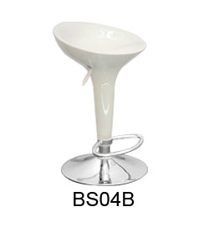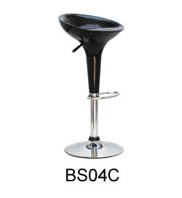 | 435*580-790H | 100.00 | BS04B/C
19 | 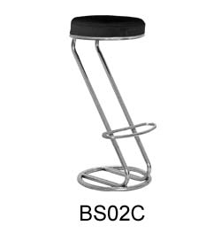  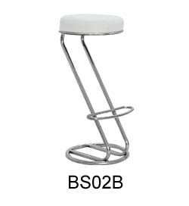 | 370*850H | 100.00 | BS02B/C
20 | 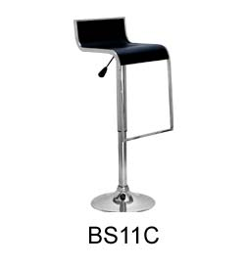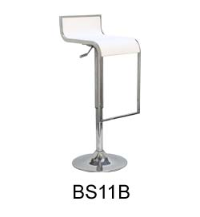 | 360*400*760-860H | 125.00 | BS11B/C
21 | 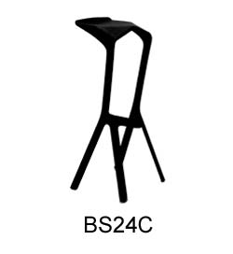 | 400*310*800H | 155.00 | BS24C
22 | 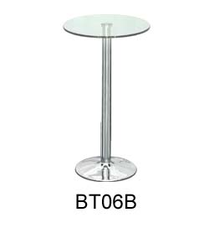 | 600*1100H | 230.00 | BT06B
23 | 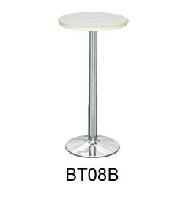 | 600*1100H | 230.00 | BT08B
24 | 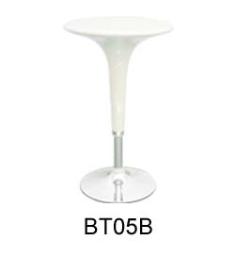 | 600*750*980H | 230.00 | BT05B
25 | 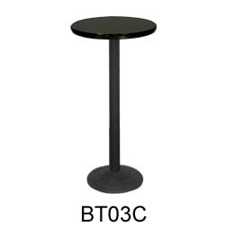 | 600*1100H | 230.00 | BT03C
DISPLAY FOLDER:
26 | 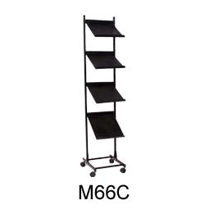 | 260 x 250 x 1200H | 100.00 | M66C
27 | 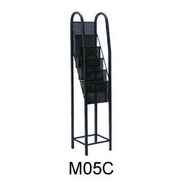 | 270*250*1200H | 100.00 | M05C
28 | 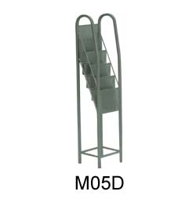 | 270*250*1200H | 100.00 | M05D
29 | 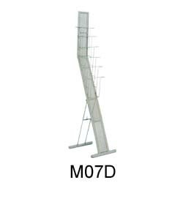 | 420*300*1400H | 100.00 | M07D
GLASS SHOWCASE:
30 | 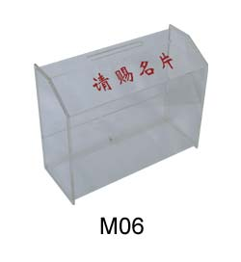 | 250*100*200H | 80.00 | M06
31 | 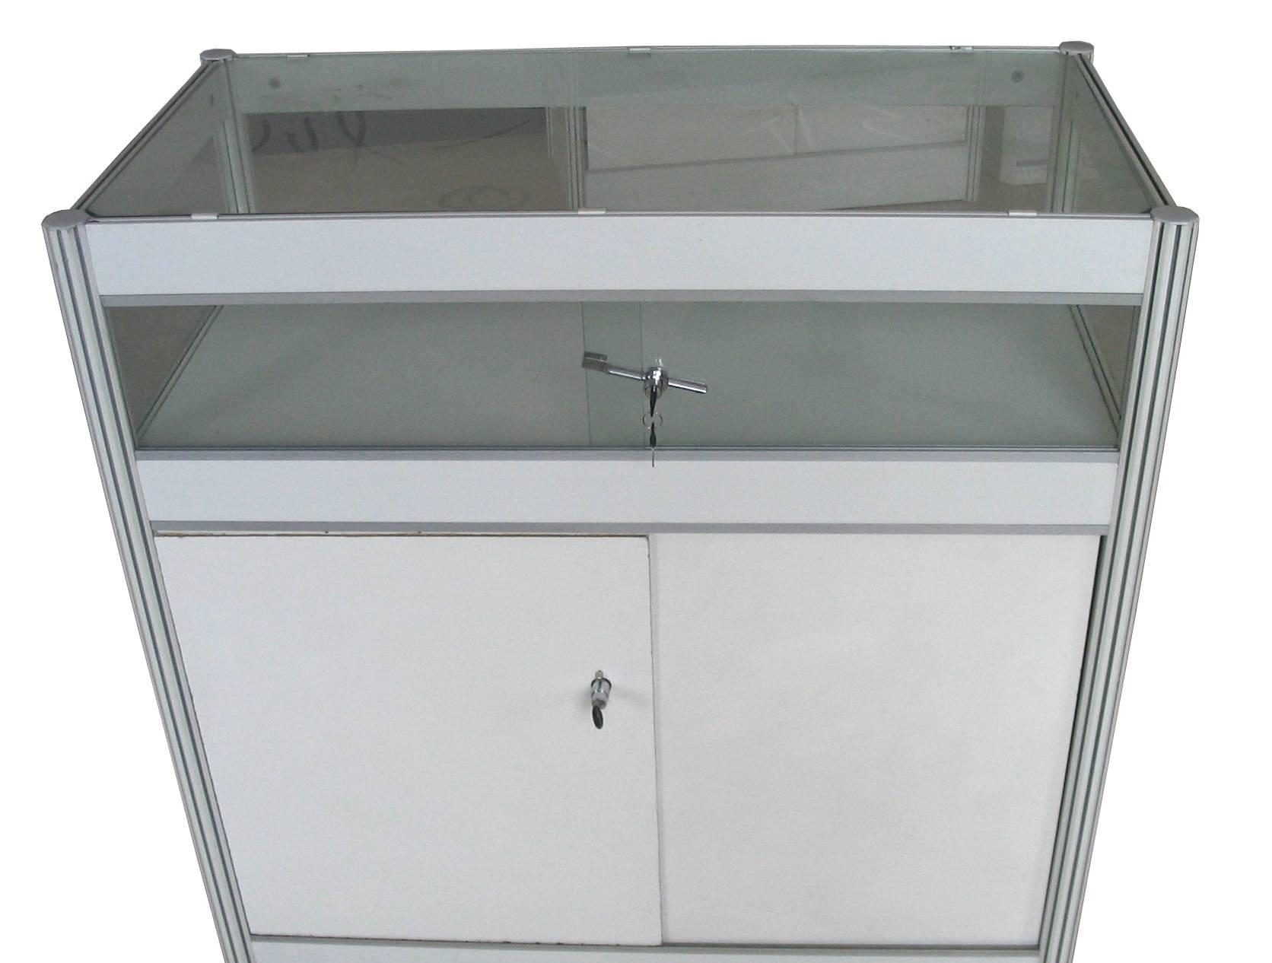 | 1030x 535 x1000H | 460.00 | M02
32 | 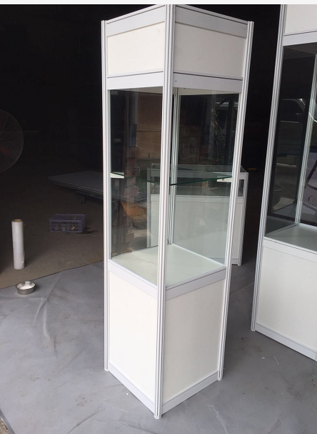 | 500x 500 x2000H | 460.00 | M04
33 | 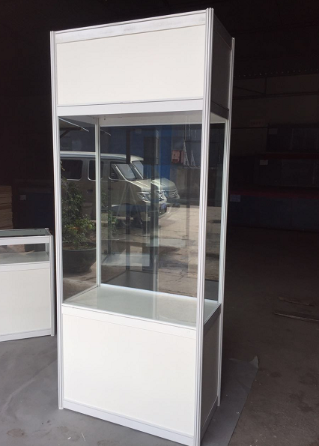 | 1000x 500 x2000H | 600.00 | M05
34 | 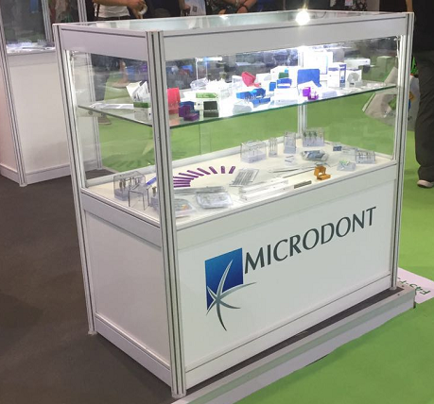 | 1000x 500 x1000H | 460.00 | M06
35 | 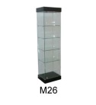 | 500*500*1800H | 600.00 | M26
WATER DISPENSER:
36 | 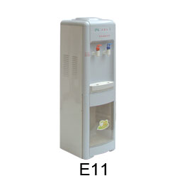 | 300x300x960H | 270.00 | E11
REFRIGERATOR:
37 | 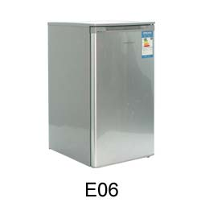 | 550 x 550 x 860H  (90L) | 550.00 | E06
CLOTHES RACK:
38 | 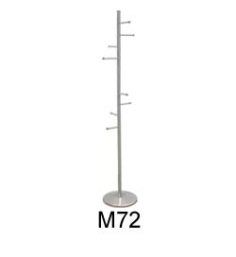 | 1710H | 90.00 | M72
SOFA AND TEA TABLE:
39 | 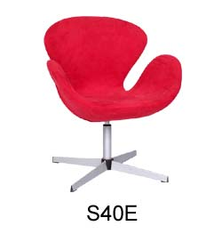 | 750*680*780H | 390.00 | S40E
 | 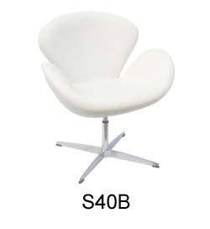 | 750*680*780H | 390.00 | S40B
40 | 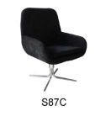 | 580*580*930H | 320.00 | S87C
 | 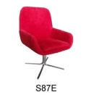 | 580*580*930H | 320.00 | S87B
41 | 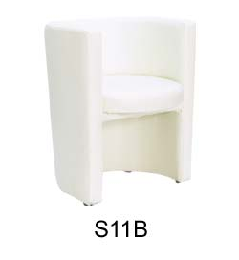 | 600*570*730H | 300.00 | S11B
42 | 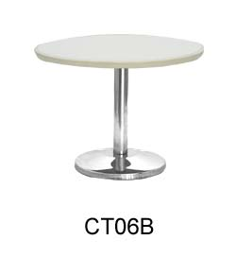 | 600*430H | 160.00 | CT06B
43 | 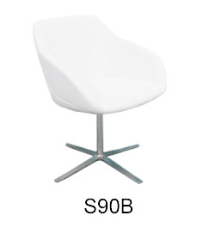 | 620*610*810H | 320.00 | S90B
AV AND COMPUTER FURNITURE
44 | lenovo 32” | LCD | 1,200.00 | P04A
45 | Plasma TV 42" | Letv,Sharp | 1,500.00 | P04B
46 | Plasma TV 50" | Letv,Sharp,Tongfang | 2,200.00 | P04C
47 | TV stand |  | 200.00 | P05
48 | Projector  3600LM | Epson | 2,000.00 | P06
49 | Projection screen 120" |  | 1,000.00 | P07

Note: if you need additional furniture service, please enter our website: www.aloxchina.com

Your Company Name:
Booth Number: Contact Person:
Tel: WeChat:
Mobile:
Total Amount of Payment:

